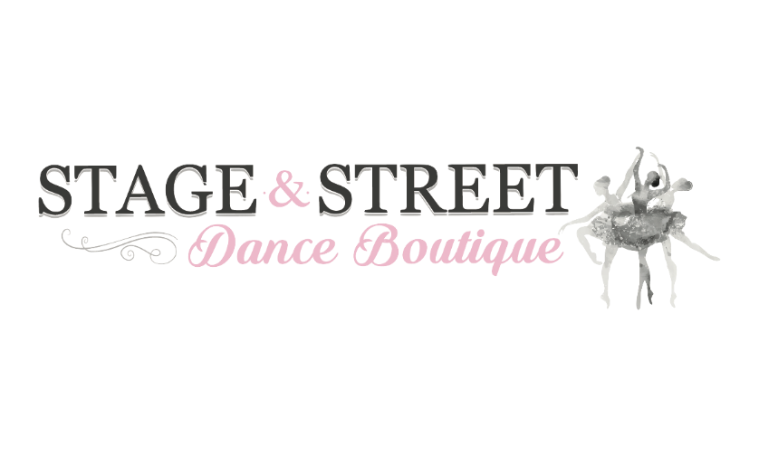

WHSPA Performing Arts Uniform Collection
Order Form
Student Name:____________________________ | Parent Name: _____________________________
Student Grade (2018): ______________________ | Parent Phone: _____________________________
Preferred Method of Contact: Phone □ Email □ | Parent Email: ______________________________
Faculty: Dance □ Drama □ | Music □
DANCE, DRAMA and MUSIC UNIFORM
Item Name | Item Size | Qty | Price
Summit Jacket | Ladies – SML □ MED □ LRG □ XLRG □  Men – SML □ MED □ LRG □ XLRG □ |  | Ladies= $120.00  Men = $120.00
T- Shirt | CHS □ CHM □ CHL □ CHXL □  ADXS □ ADS □ ADM □ ADL □ ADXL □ |  | Childs = $39.95  Adults = $44.95
Tights | CHS □ CHM □ CHL □ CHXL □  ADXS □ ADS □ ADM □ ADL □ ADXL □ |  | Childs = $59.95  Adults = $65.95
Shorts | CHS □ CHM □ CHL □ CHXL □  ADXS □ ADS □ ADM □ ADL □ ADXL □ |  | Childs = $39.95  Adults = $44.95
Trackpants | CHS □ CHM □ CHL □ CHXL □  ADXS □ ADS □ ADM □ ADL □ ADXL □ |  | Childs = $44.95  Adults = $49.95

DANCE UNIFORM ONLY (Not Compulsory)
Item Name | Item Size | Qty | Price
Training Jacket | CHS □ CHM □ CHL □ CHXL □  ADXS □ ADS □ ADM □ ADL □ ADXL □ |  | Childs = $75.95  Adults = $95.95
Singlet | CHS □ CHM □ CHL □ CHXL □  ADXS □ ADS □ ADM □ ADL □ ADXL □ |  | Childs = $44.95  Adults = $49.95

Payment Method: | Credit Card Details:
Cash □ | Card Holder Name: __________________________ | Date: ______________
Credit Card □ | Credit Card Number: _________________________ | Total Price: _________
Afterpay □ | Credit Card Expiry: __________________________
Zippay □ | Credit Card Security Code: ____________________
 | Afterpay / Zippay Code: _______________________
 | Signature: __________________________________

Please note that there are no returns or exchanges on the Summit jackets. All WHSPA orders are non-refundable.
Thank you for your purchase! Size samples are available in-store for your convenience. You will be notified via email when your order is available for collection from our store.

