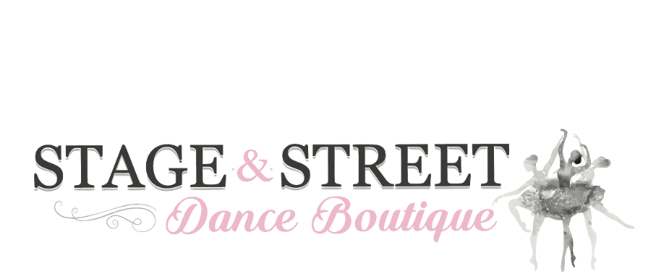

Size Guide
Summit Jacket
Ladies Size | Small (S) | Medium (M) | Large (M) | Extra-Large (XL)
Garment ½ chest (cm) | 49 | 52.5 | 56 | 59.5

Men’s Size | Small (S) | Medium (M) | Large (L) | Extra-Large (XL)
Garment ½ chest (cm) | 57 | 59 | 61 | 63

T-Shirt, Tights, Track Pants, Shorts, Singlet, Training Jacket
Children’s | Child Small | Child Medium | Child Large | Child X-Large
Size (AUS) | 6-7 | 8-9 | 10-11 | 12-13
Age (Years) | 7 | 9 | 11 | 13
Height (cm) | 125 | 135 | 145 | 155
Chest (cm) | 64 | 69 | 74 | 79
Waist (cm) | 58 | 61 | 63 | 66
Hip (cm) | 69 | 74 | 79 | 83

Ladies | Adult X-Small | Adult Small | Adult Medium | Adult Large | Adult X-Large
AUS/UK | 8 | 10 | 12 | 14 | 16
Bust (cm) | 83 | 88 | 93 | 98 | 103
Waist (cm) | 65 | 70 | 75 | 80 | 85
Hip (cm) | 93 | 98 | 103 | 108 | 113

Men’s | Adult X-Small | Adult Small | Adult Medium | Adult Large | Adult X-Large
Chest (cm) | 85 | 90 | 96 | 102 | 108
Waist (inch) | 28” | 30” | 32” | 34” | 36”

If you are unsure of sizing, please ask staff for assistance or try on a sample size provided.

