All That Jazz Dance Co
Uniform Order Form

Student Name: _______________________ | Date: _____________________________
Student Age: ________________________
Parent Name: ________________________ | Parent Phone: _______________________

ITEM | IMAGE | SIZE & QTY |  | PRICE
Energetiks  Addison Crop  CC01/ AC01 |  | CHXS= | ADXS= | Child = | Adult =
 |  | CHS= | ADS= | $29.99 | $34.99
 |  | CHM= | ADM=
 |  | CHL= | ADL=
 |  | CHXL = | ADXL=
Energetiks  Olivia Crop  CC107/ AC017 | 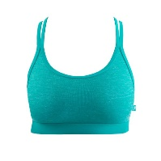 | CHS= | ADXS= | Child =  $34.99 | Adult =  $39.99
 |  | CHM= | ADS=
 |  | CHL= | ADM=
 |  | CHXL= | ADL=
Energetiks  Ashley Shorts  CAS17/ AAS17 | 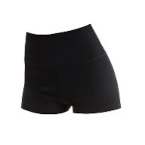 | CHS= | ADXS= | Child =  $36.99 | Adult =  $39.99
 |  | CHM= | ADS=
 |  | CHL= | ADM=
 |  | CHXL= | ADL/XL=
Energetiks  Keira Leggings  CT86 / AT86 | 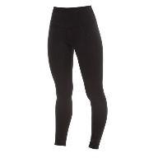 | CHXS= | ADXS= | Child =  $59.99 | Adult =  $65.99
 |  | CHS= | ADS=
 |  | CHM= | ADM=
 |  | CHL= | ADL=
 |  | CHXL= | ADXL=
Energetiks  Gia Leggings  CT95 / AT95 | 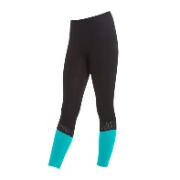 | CHS= | ADXS= | Child =  $59.99 | Adult =  $69.99
 |  | CHM= | ADS=
 |  | CHL= | ADM=
 |  | CHXL= | ADL=
Energetiks  Paisley Playsuit  MCW22/MCAW22 | 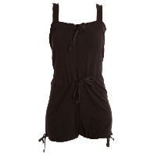 | CHS= | ADXS/S= | Child =  $64.95 | Adult = $69.99
 |  | CHM=
 |  | CHL= | ADM/L=
 |  | CHXL=

Please make payment to Stage and Street Dance Boutique at time of placing order.
NO orders will be processed without payment!
BSB: 484 799
ACCOUNT NUMBER: 124059590
REFERENCE: ATJ Uniform *Childs Name*

OR pay in-store OR pay via phone (4205 2740 / 0466 891 140)

